Parth Babbar

Certificate of deposits

**Introduction:**

A Certificate of Deposit (CD) is a financial product offered by banks, thrift organisations, and credit unions across the United States. CDs require investors to make a fixed deposit for a set length of time, which can range from a few months to several years. In exchange, the institution gives a predefined interest rate that is fixed for the life of the period. CDs, unlike savings accounts, have a fixed maturity date and often pay higher interest rates, making them an appealing choice for people looking for a low-risk investment with predictable returns.

**Features of CDs:**

1. **Fixed Term:** The time period during which money is placed in a bank, which can range from a few months to many years.
2. **Fixed Interest Rate:** The interest rate is typically fixed for the duration of the CD.
3. **Early Withdrawal Penalty:** Withdrawing money before the maturity date typically results in a penalty.
4. **Insurance:** The Federal Deposit Insurance Corporation (FDIC) insures CDs up to $250,000 per depositor and insured bank, for each account ownership type.

**Types of CDs:**

1. **Traditional CD:** Provides a fixed interest rate for a certain period.
2. **Bump-Up CD:** Allows the depositor to seek an increase in the interest rate if the bank's rates on new CDs of the same period rise.
3. **Step-Up CD:** Interest rates rise at predetermined intervals.
4. **Liquid CD:** Allows withdrawals without penalty, but often with a reduced interest rate.
5. **Brokered CD:** Sold through brokerage firms, with possibly higher interest rates but less flexibility.

There are few more types like High-yield CD, Jumbo CD, Add-on CD, etc.

**How CDs Work:**

1. **Investment:** The investor deposits funds into a CD.
2. **Term:** The deposit is kept for a specific time period (e.g., 6 months, 1 year, 5 years).
3. **Interest Rate:** The bank offers a greater fixed interest rate than a typical savings account.
4. **Maturity:** At the conclusion of the period, the investor is paid the principal plus accumulated interest.  
   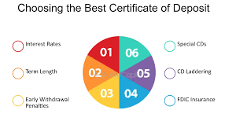

**Benefits & Drawbacks:**

**Benefits:**

1. **Safety:** FDIC-insured (up to $250,000 per depositor and institution).
2. **Predictable returns:** A fixed interest rate provides consistent revenue.
3. **Low risk:** Holding to maturity preserves the principal.

**Drawbacks:**

1. **Early withdrawal penalties:** Losing interest or incurring costs if accessed before maturity.
2. **Limited liquidity:** Funds are locked up for the duration.
3. **Risk of lesser returns:** Fixed rates may not keep up with inflation or market gains.

**Regulatory:**

CDs are subject to FDIC rules, which cover deposits and protect customers in the event of a bank failure. The Truth in Savings Act compels banks to offer explicit terms and conditions, including the annual percentage yield (APY), so that customers may make educated decisions.

**Statistics:**

**CD Rates:**

1. In 2024, interest rates on CDs in the United States will vary depending on the duration and banking institution. Here are the average rates:  
    1. **1-Year CD:** 4.75% - 5.25%  
    2. **3-Year CD:** 4.50% - 5.00%  
    3. **5-Year CD:** 4.25% - 4.75%
2. The COVID-19 epidemic had a significant impact on the economy. From February 2020 to May 2020, three-month CD rates declined from 1.59% APY to 0.17%, where they stayed very stable until December 2021. Interest rates rose in January 2022, resulting in a solid 5.32% annual percentage yield in December 2023. Since then, rates have consistently maintained around 5% APY, with current rates hanging close or slightly above 5.5% APY.  
   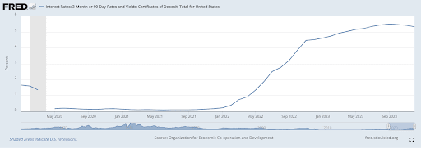

**Market:**

Total CDs holdings at the end of 2023 were $2.870 Trillion.

**Conclusion:**

Certificates of Deposit are still a popular investment option in the US banking sector due to their safety, guaranteed yields, and predictability. Despite these drawbacks, they are a useful tool for conservative investors seeking to conserve money while earning a moderate return.